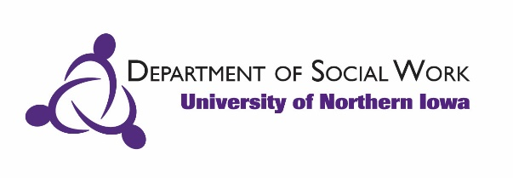
FIELD INSTRUCTION – DOCUMENTATION OF HOURS
*Due at the end of the field experience signed by all parties.

GUIDELINES: TRAVEL TIME, PROFESSIONAL DEVELOPMENT TRAININGS, LUNCH BREAKS, FEDERAL/STATE/AGENCY HOLIDAYS
What can be counted as hours | What cannot be counted as hours
Travel to meetings, other agencies, client homes | Travel to and from the agency from place of residence
Travel to and from seminar if agency is outside the Cedar Valley (Waterloo, Cedar Falls, Waverly); Attendance at seminar (up to 40 hours) | Travel to and/or from seminar if it is at the beginning or end of work day
Lunch breaks that involve direct client contact or when traveling for internship related activities over the lunch break | Travel to professional development sessions if over 2 hours away, including overnights prior to or after the professional development session
Professional development sessions, if approved by your agency instructor | Lunch breaks
Travel to professional development sessions if under 2 hours away | Federal, state and/or agency holidays in which students did not complete field experience activities towards their field hours.
Webinars and/or book reads, if approved by your agency instructor/supervisor. Limits to how many hours can apply are recommended. | On call hours when not engaged in on call activities or other relevant learning activities assigned by site supervisor.
*any special circumstances should be discussed with your agency instructor and faculty liaison for approval.

Student name:
Semester/Year:

EXAMPLE:
WEEK | DATES | HOURS WORKED | CUMULATIVE HOURS
May 11, 2015 | May 11 | 7
 | May 12 | 8
 | May 13 | 6
 | May 14 | 7
 | May 15 | 7 | 35
May 18, 2015 | May 18 | 5
 | May 19 | 7
 | May 20 | 6
 | May 21 | 8
 | May 22 | 7 | 68
May 25, 2015 | Etc….

HOURS:
WEEK | DATES | HOURS WORKED | CUMULATIVE HOURS
TOTAL HOURS:

_________________________________________ __________________
Student's Signature Date

_________________________________________ __________________
Agency Field Instructor's Signature Date

_________________________________________ __________________
UNI Social Work Faculty Liaison's Signature Date

Revised Feb 2021

